Section A: Getting Started
1 | Open a web browser and type crowd.library.wales/en/s/livingstone in the address bar, and then press Enter.  The National Library of Wales would encourage you to use a recent version of a modern web browser such as Firefox or Chrome when contributing to this platform. | 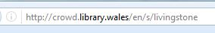
2 | If you are visiting this site for the first time you will need to register by clicking the Sign Up link on the top right hand of the screen and following the instructions on the next screen to create an account.  If you are returning to the site, then you can start working immediately by clicking on Login and entering your details. | 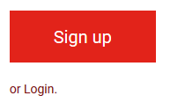
3 | Now that you are ready to start contributing to the collection click on Get Started and then choose one of the collections, and click on View whole collection | 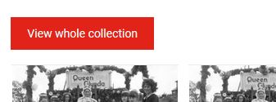
4 | On the next page you can choose which item you would like to annotate, or if you are returning to the site, you can continue annotating an item that you started working on previously.  The colour below the item indicates its status.  - The small red square and grey bar at the bottom indicates that no one has worked with this image.  - The orange bar across half of the bottom indicates that work has started on annotating this image, but that it has not been completed.  - If the bar across the bottom of an image is green, then the annotation on this image is complete.

If you want to edit an item that has no annotations (red square) move on to Section B.
If you are editing an item that has already been partially annotated (orange bar) move on to Section C.
Section B: Annotating an item for the first time
1 | Click on the image that you wish to annotate. Before you can begin working with this item you will need to choose what type of information you wish to contribute. You can hover on the question marks for guidance.
2 | You can use the ‘+’ and ‘-‘ signs or the wheel on your mouse to scroll in and out. Hover on the question marks for guidance.  Describing a Whole Photograph:  Fill in as much information as you possibly can in the text fields on the right hand side of the screen.  Please overwrite the calendar by typing dates in this format: DD/MM/YYY.  To record where the photo was taken, type the name of the town or village, then use the map to choose the exact location.  If you don’t have more information, leave the box blank.  Once you are finished you should click on Next > and then on the red Save button below the text. | 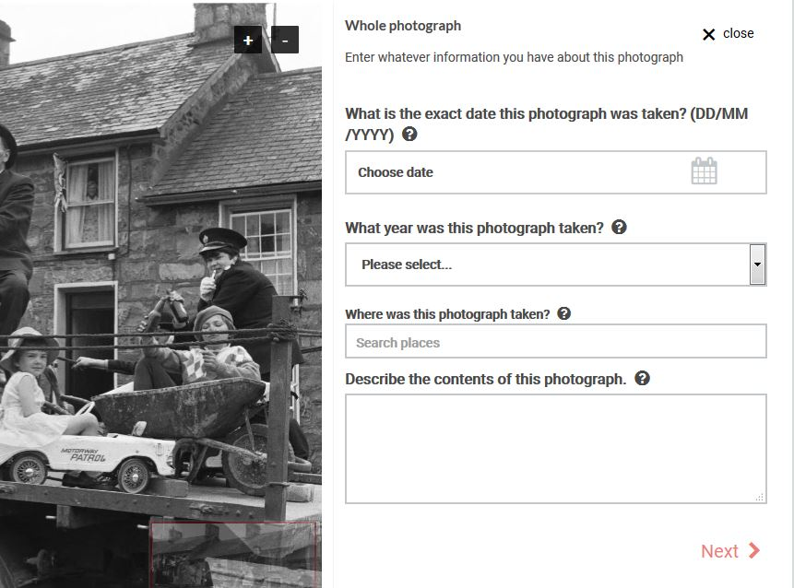
3 | 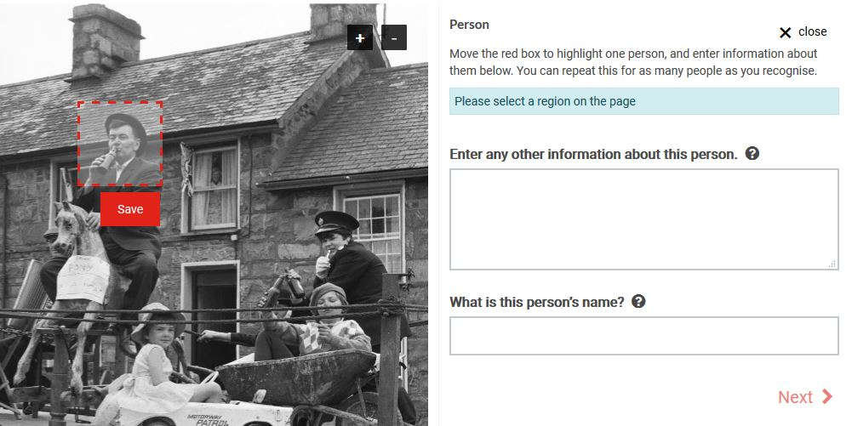 | Describing a person:  Drag the red box across the photo and adjust its size until it fits around the face of the person you want to describe. Click ‘save’ under the red box.  Record information about this person in the text boxes.  You can repeat this for each person that you want to describe.  Once you are finished you should click on Next > and then on the red Save button below the text.
4 | Memories:  Record any memories of the content of the photo.  The text box will expand as you type.  If you don’t have any information, please leave the box blank.  Once you are finished click on Next > and then on the red Save button below the text. | 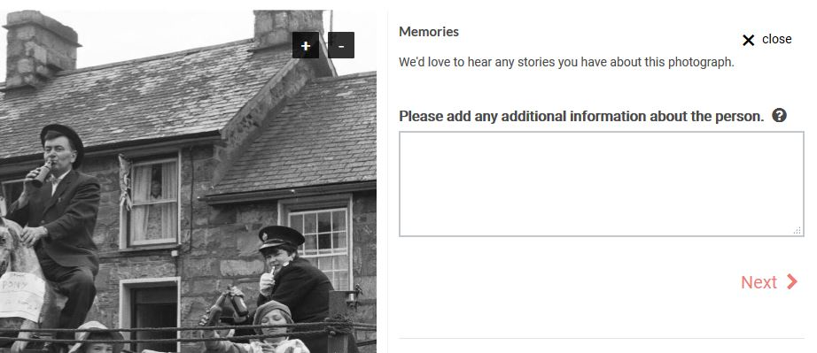
5 | 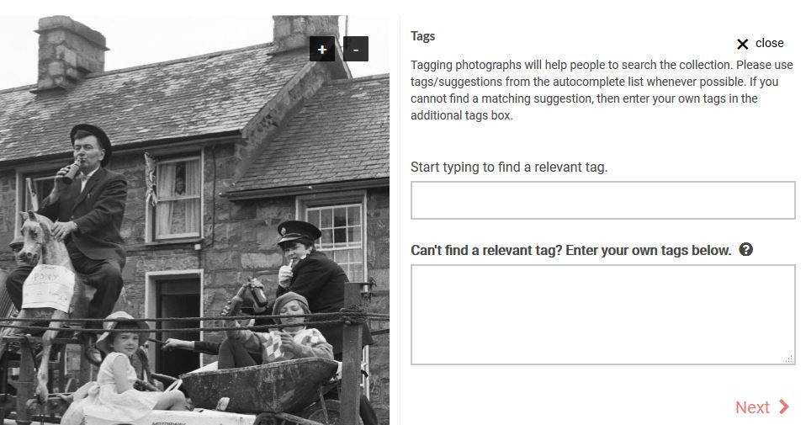 | Tagging:  Tagging photographs will help people to search the collection.  Please use tags/suggestions from the autocomplete list whenever possible.  If you cannot find a matching suggestion, then enter your own tags in the additional tags box.  If you don’t want to add tags, leave this box blank.  Once you are finished click on Next > and then on the red Save button below the text.
6 | Once saved you can also Bookmark the page by clicking the button on the bottom right of the screen. All your bookmark selections can be viewed by clicking on your name in the top right of the page – this is the best way of finding documents you’ve previously worked on.  If you finish annotating the whole page you can use the button on the bottom right of the screen to mark that page as complete. This will change its status to green (Mark as complete).  Scroll to the carousel at the bottom of the screen and choose the next photo you wish to describe. |  | 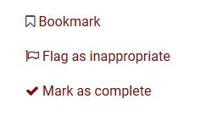

Section c: editing an item that has already been partially annotated
1 | Images that have an orange bar across the bottom have been partially annotated. You may wish to work on this type of image by:  - Editing your own annotations and returning to annotate an image that you have already begun working on.  - Editing annotations that others have started but have not completed.  - Adding new annotations to images that have already been partially annotated.  First you will need to click on the image to take you to the annotating page. |  | 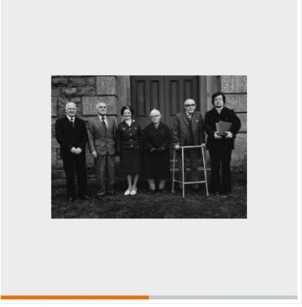
2 | Below the image you will see thumbnails representing annotations that already exist. If you wish to edit one of these, click on the annotation and a new dialogue will appear with an < Edit button.  Click on this button to edit the annotation, and then click Next > and then Save once you are finished.  If you finish annotating the whole item you can use the button on the bottom right of the screen to mark that page as complete as shown in step 6 of Section B. | 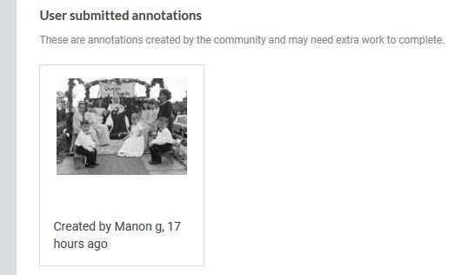
3 | If you wish to add a new annotation then you will need to follow the steps outlined in Section B: Annotating an item for the first time.

